#10 20-foot Shipping Container Storage Shed 280424

South Elevation (6.06m) West Elevation (2.44m) Door facing East West and South Elevations

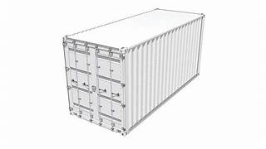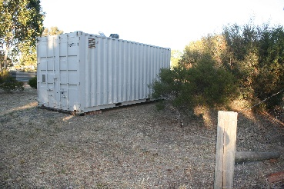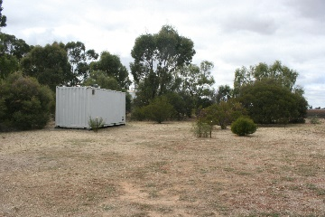
(Looking South West) (Looking East)
East Elevation (2.44m) North Elevation (6.06m)
Height (2.59m)

NB:
The above photos show the whirly gig in the roof and side vents installed for ventilation against internal condensation.
The container is painted Dove Grey as a neutral colour to blend-in with the surroundings.
The following CAD sketches of a standard 20-foot container, are indicative of the measurements of the container at 13 Picola South Road, Picola.

