#3 Summary of Supporting Evidence for Planning Permit Application 280424

Address Location:
Street Address: 13 Picola South Road, Picola 3639
Vol. 03088 Folio 421

Land Description:
Lot 1 on Plan of Subdivision 004122
Parent Title: Volume 01729 Folio 722
Created by Instrument: 0510976 24/10/1905
Parish: Parish of Narioka

Current Use of Property:
Vacant 0.1300ha block of land.
One of 5 sub-divided lots in a row.
It is not subject to any overlays.
The property’s AVPC code is “100” – Residential Vacant – and is rated accordingly.
The property is currently serviced with both reticulated electricity and potable water supplies.
Picola South Road is an all-weather, sealed road.
All the blocks are too small to run any form of farming activity and are only suitable as residential land.

Crossover:
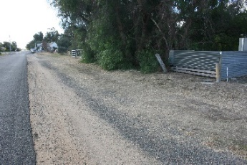

Proposal:
To construct a single story 2 bedroom cottage with attached single car carport and driveway crossover
and to maintain a 20-foot shipping container for machinery storage.

Application Fee:
Although the property is zoned Farming, there are already 2 other occupied dwellings on these lots, plus the lot next door to me was resided on until a severe fire destroyed it. None of these homes on this sub-division has had a Planning Permit issued, and this has facilitated dwellings now to be built upon it.
I now ask that the relative Planning Permit Fee be waived on this occasion.

